Nick Cardamone

ncard024@uottawa.ca

300060019

Oct 27, 2020

lab Two: Wave Reflection and Transmission

Electromagnetic Engineering ELG 3106A

# Introduction

When a wave hits a boundary, it can reflect or refract. An electromagnetic wave will usually do both. In this simulation lab, we will be studying the conditions of reflection, refraction and transmission at oblique incidence. Figure one shows that the standard view of the EM field phasor can be seen; this will provide a grounding point for the rest of this lab.

This lab's objective is to produce a plot of Reflectivity and Transmissivity vs an incident angle ranging from 0 to 90 degrees.

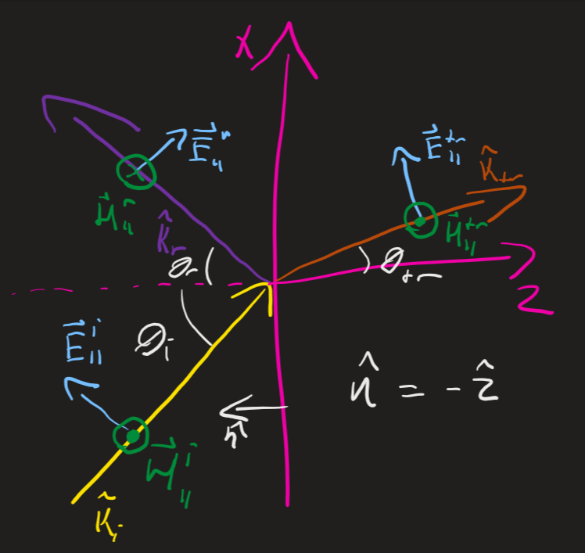

Figure : Standard View of EM Wave at a Boundry

# Theory

An electromagnetic wave at a boundary can be considered transverse electric (perpendicular polarization), transverse magnetic (parallel polarization), or a linear combo of both. A TE polarization is one where the electric field is normal to the plane formed by the normal to the interface and the direction of propagation of the wave. This is called the plane of incidence. A TM polarization is one where the magnetic field is normal to the plane of incidence.

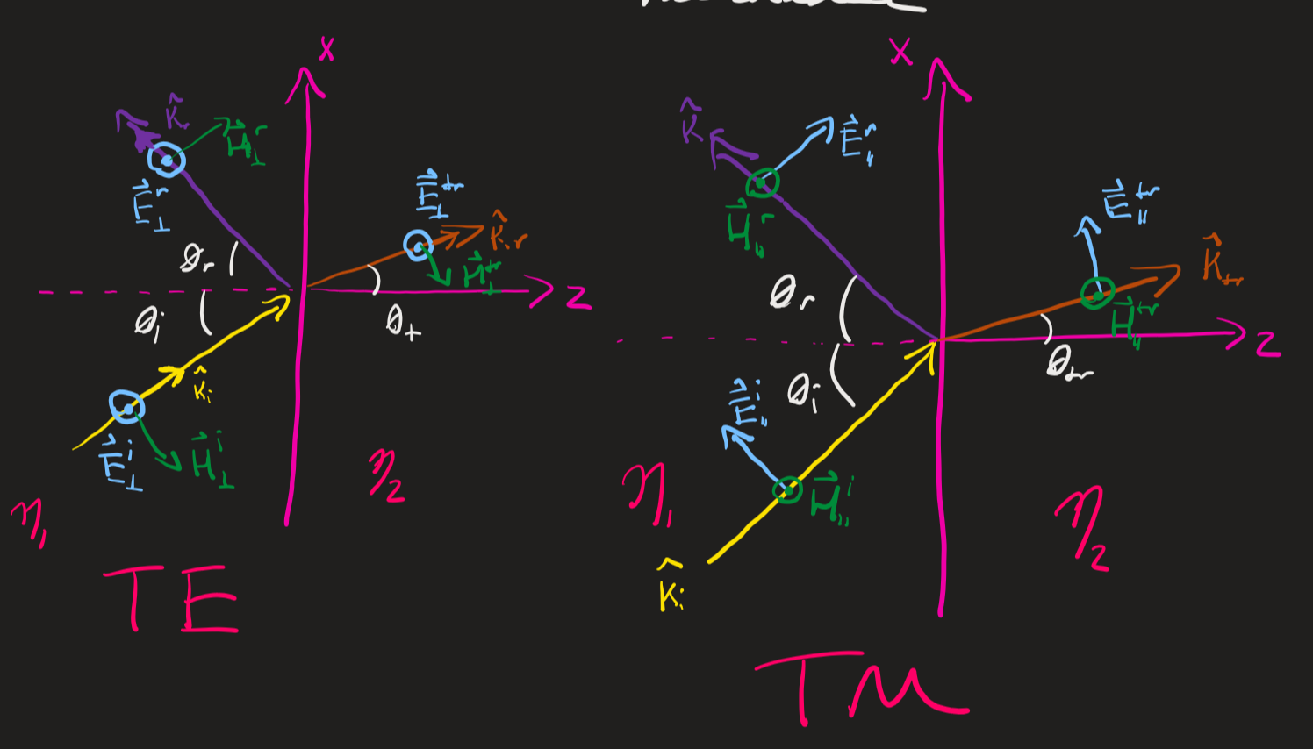

Figure : Transverse Electric and Transverse Magnetic EM Fields

For the remainder of this discussion, we will focus on the electric field component for simplicity.

When the electric field hits an interface, the reaction can be characterized by two parameters, the reflection (Γ) and transmission (τ) coefficients. The transmission coefficient is the ratio of the transmitted field to the incident. The reflection coefficient is the ratio of the reflected field to the incident.

For the transverse magnetic case, there exists a special case where the reflection coefficient is zero. This is called the Brewster angle and is given by

[1]

The angles of refraction are given by Snell’s law as follows

[2] [3]

The reflectivity and transmissivity are simply the squares of the corresponding reaction coefficient. The rest of the formulas can be found below

Table : Reflection and Transmission Formulas

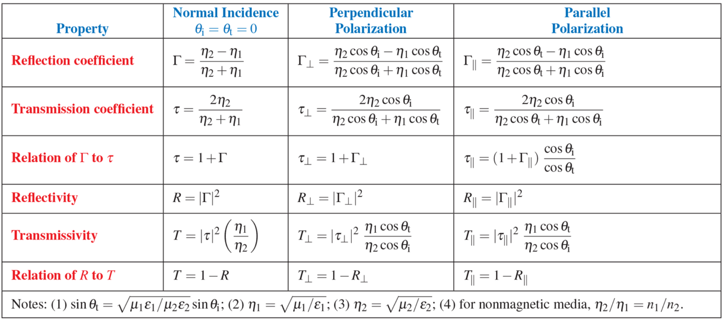

# Simulation Results

## MATLAB Results

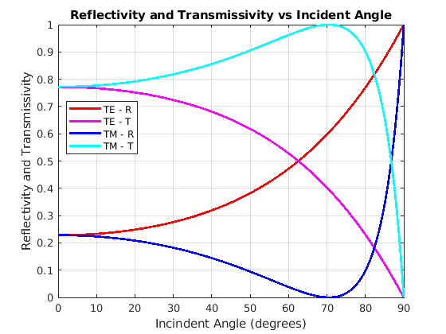

Figure : MATLAB Plot of Reflectivity and Transmissivity

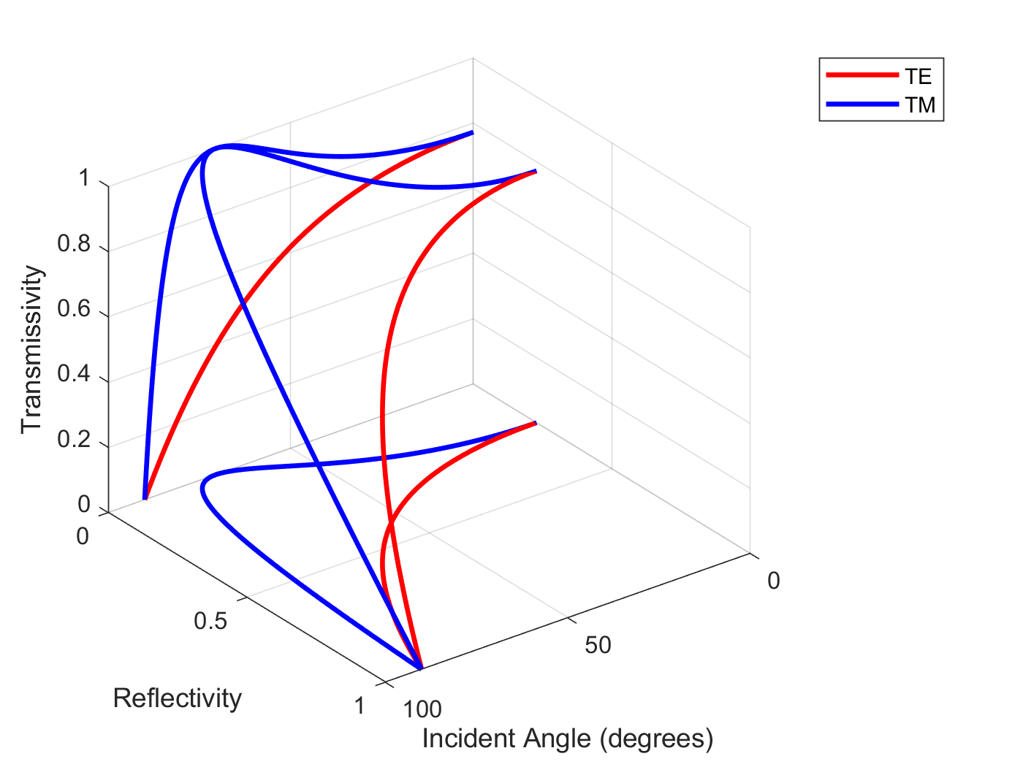

Figure : 3D MATLAB Plot of Transmissivity and Reflectivity

## Java App Results

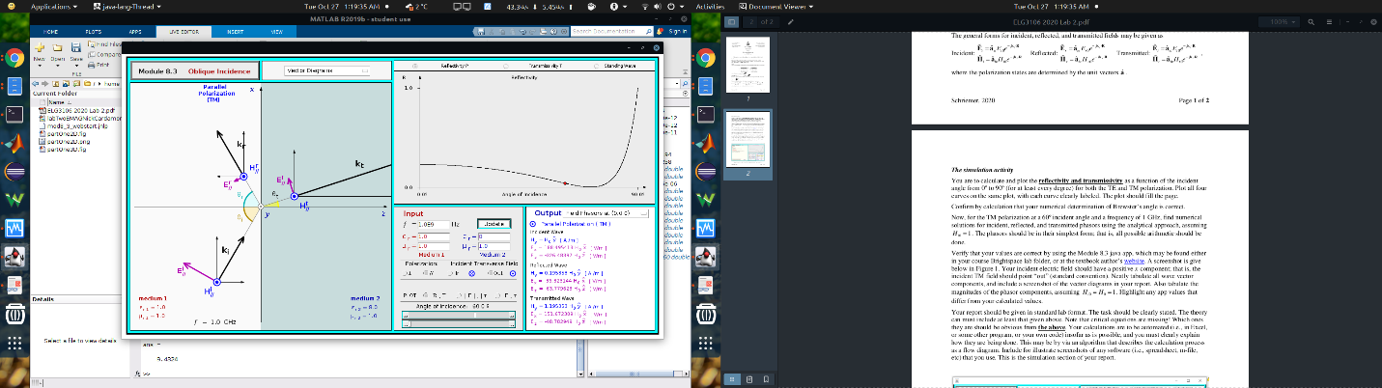

Figure : Java App Simulation

## Paper Calculations

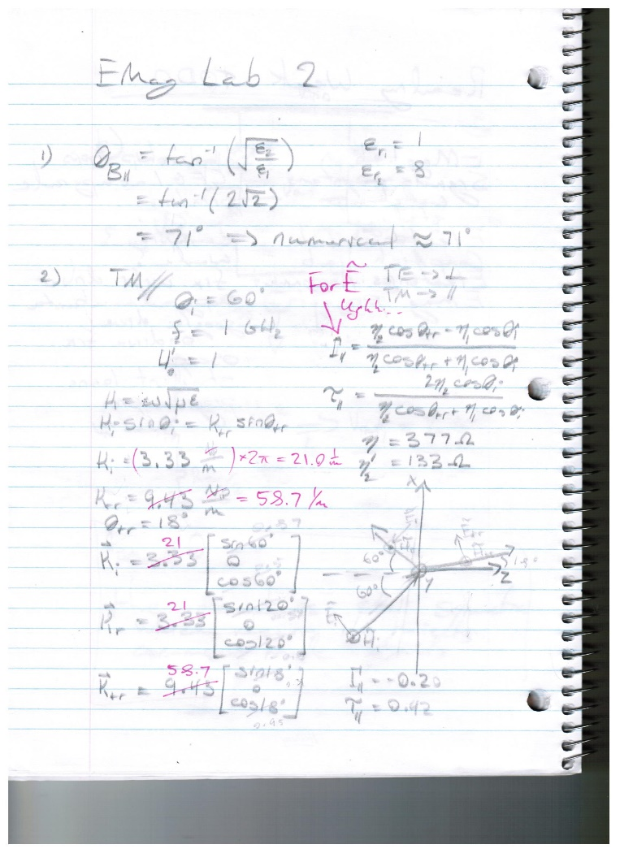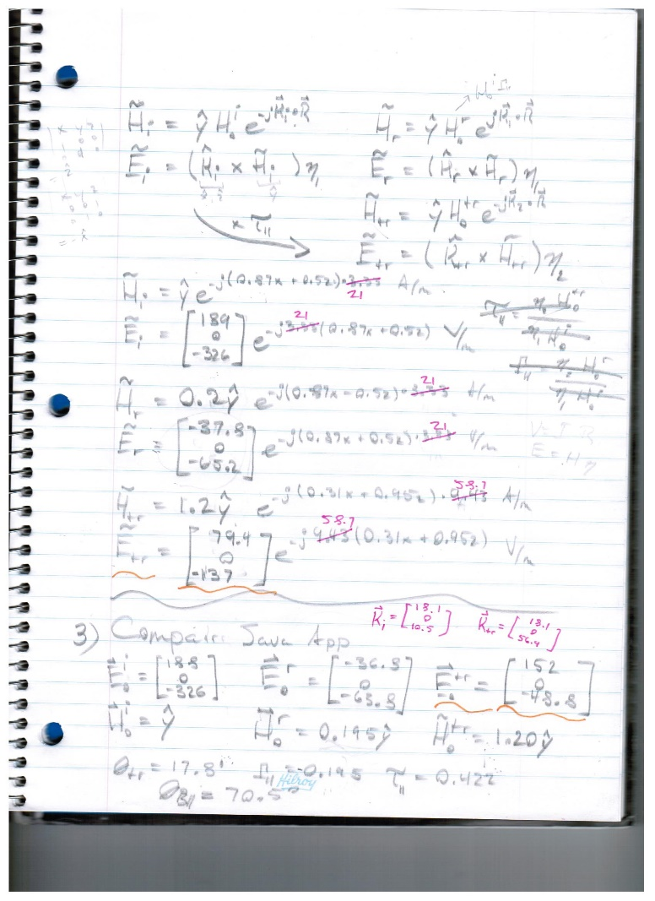



Figure : Paper Calculations Page One Figure 7: Paper Calculations Page Two

## Wave Reflection and Transmission Results

Table : Java App and Calculation Results

|  |  |  |  |
| --- | --- | --- | --- |
| Value | Paper Calculations | Java App | Unit |
| Θt | 18 | 17.8 | Degrees |
| ΘB | 71 | 70.5 | Degrees |
| ΓTM | -0.20 | -0.195 | ---- |
| τTM | 0.42 | 0.422 | ---- |
|  |  |  | V/m |
|  | -37.8 | -36.8 | V/m |
|  | 150 |  | V/m |
|  |  |  | A/m |
|  | 0.2 |  | A/m |
|  | 1.2 |  | A/m |
|  |  |  | 1/m |
|  |  |  | 1/m |

## Software Explanation

The MATLAB code is relatively simple, so this explanation will be rather brief. The goal of the code is to produce a plot of reflectivity and transmissivity for TM and TE as a function incident angle. The incident angle varies from 0 to 90 degrees. The transmission angle is calculated from snells law. The intrinsic impedances are calculated constants. Then reflectivity and transmissivity are calculated and plotted in 2D and in 3D using “plot3”.

# Discussion

The java app, paper calculations and MATLAB code all agree with each other within plus or minus a rounding error. While doing the calculations the first time, a number of problems were encountered, such as the reaction coefficients relating the electric field magnitudes, not the magnetic field one we were given. Another mistake was forgetting a 2pi in some calculations. Another was using the electric field components instead of the magnitude for transmission calculations.

As for the plots, they’re pretty much identical between the java app and the MATLAB code. The Brewster angles also agreed between the different approaches. I did end up adding a 3D plot of reflectivity and transmissivity vs incident angle just for the fun of it.

# Conclusion

In conclusion, all three methods explored in this lab, the java app, the MATLAB numerical approach and the analytical approach, converged on the same results for all parts of this lab.

# Appendix I: MATLAB Code

%EMAG Lab 2 ---- Part 1

%Constants

epsilon_0 = 8.85E-12;

mu_0 = 4E-7*pi;

zero = zeros(360);

%Given

epsilon_r_1 = 1;

epsilon_r_2 = 8;

theta_i = linspace(0,90,360);

theta_i_rad = pi*theta_i/180;

%Find

epsilon_1 = epsilon_r_1*epsilon_0;

epsilon_2 = epsilon_r_2*epsilon_0;

eta_1 = sqrt(mu_0/epsilon_1);

eta_2 = sqrt(mu_0/epsilon_2);

theta_tr_rad = sin(theta_i_rad)*sqrt(epsilon_r_1/epsilon_r_2);

theta_tr_rad = asin(theta_tr_rad);

gamma_perp = eta_2*cos(theta_i_rad)-eta_1*cos(theta_tr_rad);

gamma_perp = gamma_perp./(eta_2*cos(theta_i_rad)+eta_1*cos(theta_tr_rad));

tau_perp = 2*eta_2*cos(theta_i_rad);

tau_perp = tau_perp./(eta_2*cos(theta_i_rad)+eta_1*cos(theta_tr_rad));

gamma_par = eta_2*cos(theta_tr_rad) - eta_1*cos(theta_i_rad);

gamma_par = gamma_par./(eta_2*cos(theta_tr_rad) + eta_1*cos(theta_i_rad));

tau_par = 2*eta_2*cos(theta_i_rad);

tau_par = tau_par./(eta_2*cos(theta_tr_rad) + eta_1*cos(theta_i_rad));

R_perp = abs(gamma_perp).^2;

T_perp = abs(tau_perp).^2;

T_perp = T_perp.*((eta_1*cos(theta_tr_rad))./(eta_2.*cos(theta_i_rad)));

R_par = abs(gamma_par).^2;

T_par = abs(tau_par).^2;

T_par = T_par.*((eta_1*cos(theta_tr_rad))./(eta_2.*cos(theta_i_rad)));

%Plotting

set(gcf,'Visible','on')

plot(theta_i, R_perp, 'r', 'LineWidth', 2)

hold on

plot(theta_i, T_perp, 'm', 'LineWidth', 2)

plot(theta_i, R_par, 'b', 'LineWidth', 2)

plot(theta_i, T_par, 'c', 'LineWidth', 2)

grid on

title('Reflectivity and Transmissivity vs Incident Angle')

xlabel('Incindent Angle (degrees)')

ylabel('Reflectivity and Transmissivity')

%3D Plotting

hold off

set(gcf,'Visible','on')

p1 = plot3(theta_i, R_perp, T_perp, 'r', 'LineWidth', 2, 'DisplayName', 'TE')

hold on

p2 = plot3(theta_i, R_perp, zero, 'r', 'LineWidth', 2)

p3 = plot3(theta_i, zero, T_perp, 'r', 'LineWidth', 2)

p4 = plot3(theta_i, R_par, T_par,'b', 'LineWidth', 2, 'DisplayName', 'TM')

p5 = plot3(theta_i, R_par, zero, 'b', 'LineWidth', 2)

p6 = plot3(theta_i, zero, T_par, 'b', 'LineWidth', 2)

grid on

xlabel('Incident Angle (degrees)')

ylabel('Reflectivity')

zlabel('Transmissivity')

legend([p1,p4])